**Importing Data from Microsoft Query and ODBC connection**

**STEP 1:** Choosing datasource to import data.

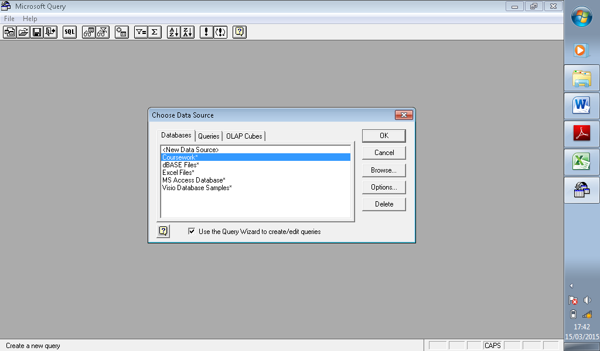

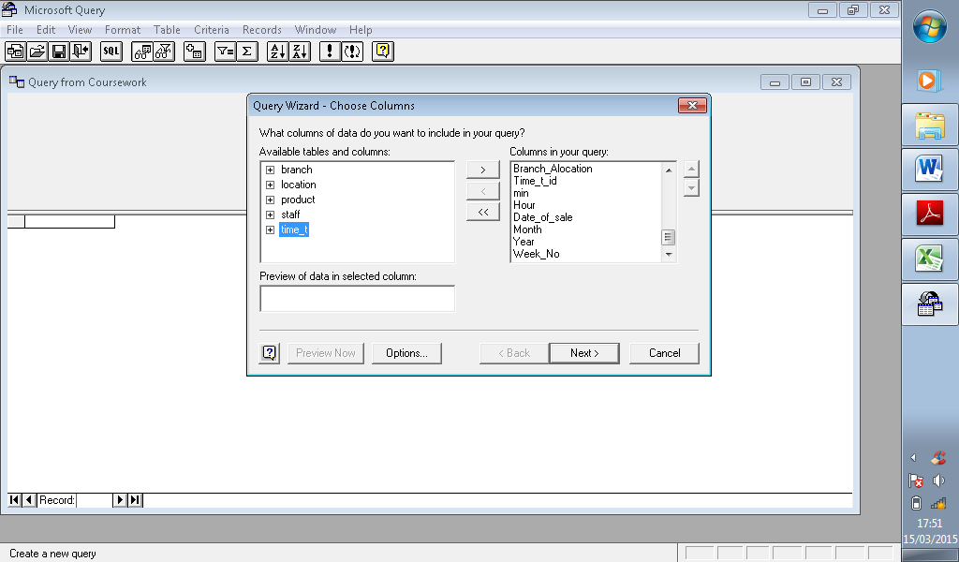**STEP 2:** Then using the query wizard to add all the tables created.

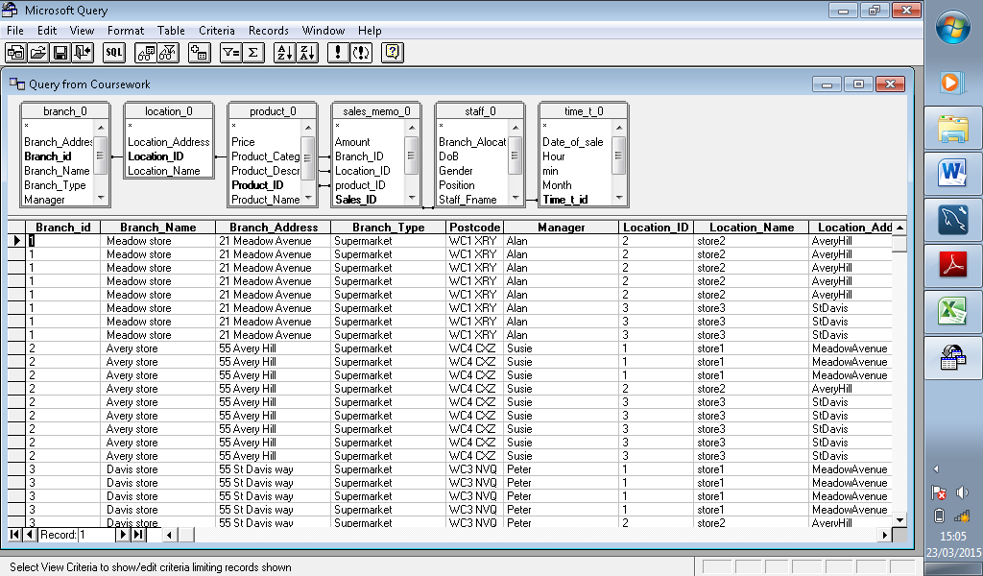**Step 3:** Outcome/result

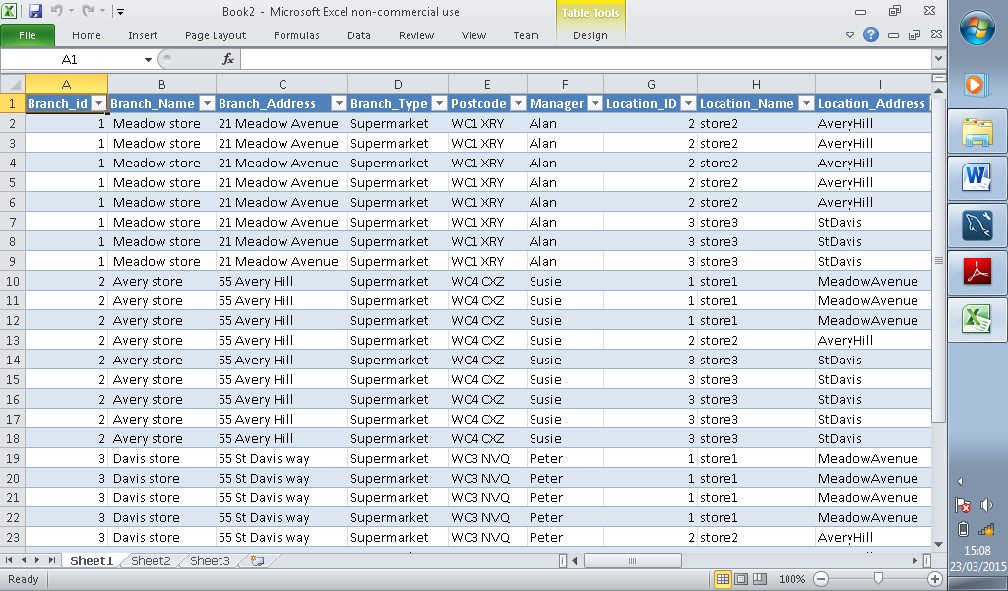 **Data returned from one query that I will be using for visualisation**